Computer Language Diagrams

Relations in a Diagram
The concept of relations is explained in the article Relations. This article only explains its expression in a diagram.

As explained in the article Related Classes in a Diagram, a unary relation between one class and another can look like this:

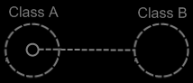

Because Class A has a sub-object of Class B, this relates Class A to Class B.
However, Class B does not have a relation back to Class A. The picture below, adds the relation back to Class A:

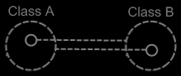

But these two unary relations will not be synchronized to eachother. An object of Class A can refer to an arbitrary object of Class B, which refers to an arbitrary object of Class A again.

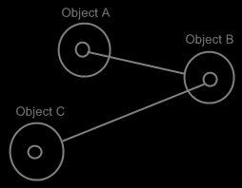

It doesn’t make the two objects refer to eachother. It just makes the two objects refer to an arbitrary object of the other class, but not necessarily to eachother.
For this, relation synchronization is applied, so that the first object and the second object always refer to eachother.

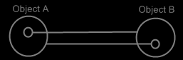

When the two following unary relations are synchronized,

then the two class lines merge together, to form the picture below:

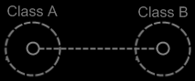

This seems to create ambiguity in the notation of the diagrams, because the two smaller circles are tied together with a class line, which suggests that they are both the same class. But the circle inside Class A represents Class B and the circle inside Class B represents Class A.

It is an implicit notation, that is the result of a line merge.

Fortunately the notation is disambiguated by a notational rule that is imposed by the concept of automatic containment. If both smaller circles represent the same class, say Class C:

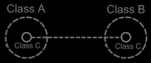

then the class itself is defined inside a container that encloses both references to Class C. Class C has to be defined on a level higher:

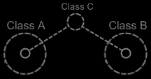

Automatic containment is explained in the article Automatic Containment.
If automatic containment is applied, then the notation for a synchronized dual relation is no longer ambiguous to expressing two symbols have the same class.

Don’t see it, like class lines have been abused to form this implicit notation. The two unary relations are so closely tied together, that they merge into a single relation. It is the clearest way to express the tight bond between classes.

The picture above expresses a 1 → 1 relation between Class A anc Class B. But other multiplicities can also be used. The multiplicity of n is expressed with a nonagon:



A nonagon represents a list of things. Instead of letting a Class A contain a single item of Class B, you can let is contain a list of items of Class B:

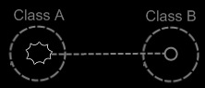

The picture above expresses an n → 1 relation between Class A and Class B.
The picture below displays a 1 → n relation between Class A and Class B.

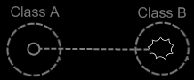

Finally, the picture below displays an n → n relation between Class A and Class B.

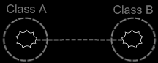

One related list can also contain items from multiple classes. Class A has a n → 1 relation to items of Class B and Class C, it is expressed as follows:

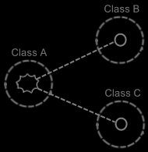

Relation to a Pointer
You can also establish a unary relation with a pointer to another class. This is not so common, but it is possible all the same.

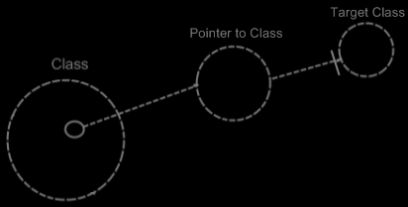

This is mostly applied, to allow a class to make a sub-object’s class adjustable.

It is important to consider, that everything inside a pointer is really part of the target class, but a pointer itself is usable individually, independent from the target class.

To make a relation to a pointer dual, you have to give the target class a relation back to the first class.

The relation back can be displayed in both symbols, that represent the target class:

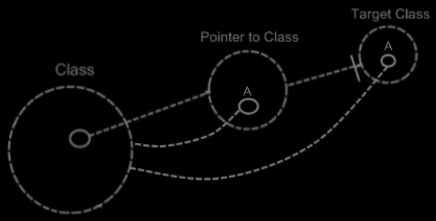

The two unary relations between Class and Pointer to Class melt together to a single dual relation. But the unary relation from the Target Class to the Class stays unary, because Class does not directly relate to Target Class:

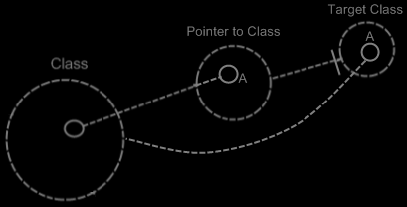

So only Class and Pointer to Class get a dual relation to eachother.
Target Class keeps a unary relation to Class. Funny enough, that unary relation is part of the dual relation between Class and Pointer to Class. The dual relation actually consists of:

- Class relates to Pointer to Class
- Target Class relates back to Class

The connection between Target Class and Class is already implied by the connection between Pointer to Class and Class. You’re allowed to leave out of the diagram then:

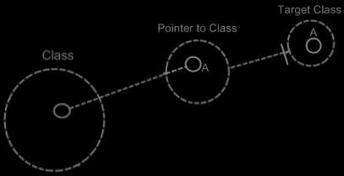

Target Class and Class are already implicitly related to eachother through the pointer to the target class.

In all the diagrams above, that display the backward relation, the sub-symbols of Pointer to Class and Target Class were given a name: A. This was done, because there was no line in the diagram to indicate that they were the same sub-object. Officially, when symbols share an aspect, in that they are equal in object, class, interface or definition, they should be tied together with a line. Officially an object line should have been connecting both symbols of A:

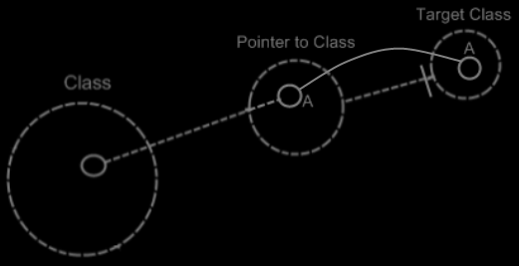

But similarity in aspect can also be implied by a name and the connection between parents. This kind of implicit connection is explained in the article Automatic Containment.
The only point to implicit connection through parent is to make the diagram clearer.

Example
Classes and their relations define the behavior of your system, so it is very important to be aware of them, instead of just looking at individual objects, tied to other objects.

The example below is part of the class-relation structure of a drawing program.
It displays the classes Application, Document, Point and Line.

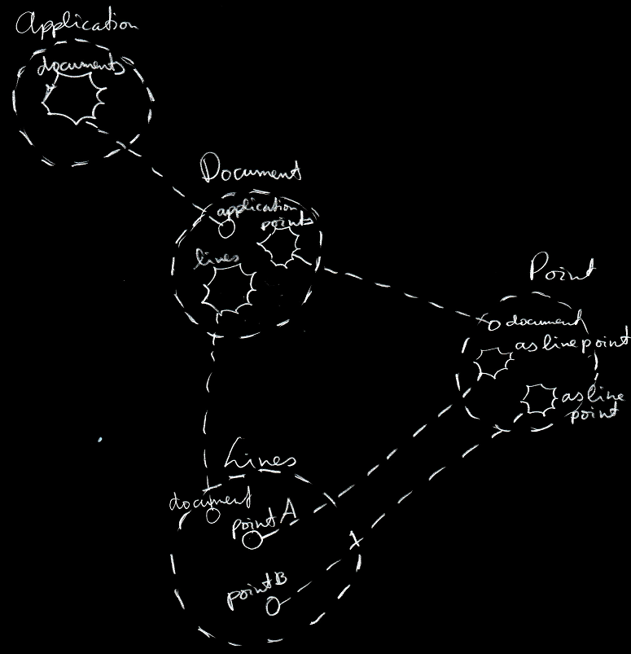

An instance of the application can hold multiple open documents. So Application has a 1 → n relation with Document. That automatically makes a document part of one instance of the application. A document holds a collection of points and a collection of lines. That makes Document have a 1 → n relation with Point and a 1 → n relation with Line. This automatically makes Points and Lines part of a single document. Furthermore, a line is composed of two points. However, if you chain lines together, a point can become a part of multiple lines. This gives Line two 1 → n relations with a Point: one for the first point and one for the second point.

The example displays all the classes, relations, related items and related lists of the object structure.

If just the use of dashed lines does not emphasize the classes and relations enough, a coloring could be applied to the diagram, highlighting all the classes and relations.

See also: Relations, Related Classes in a Diagram

Author & Copyright: Jan-Joost van Zon Date: May 21, 2008 – June 1, 2008 Location: Oosterhout, The Netherlands Status: Finished

